Get the Right Care in the Right Place
You can get medical help and advice quickly, safely and often closer to home by using these services:
- Visit NHS inform online for advice on common symptoms and a list of local services
- Speak to your pharmacist first for advice on minor illnesses
- Contact your GP during normal opening hours for routine or urgent care appointments

- Call 111 free anytime day or night if you:
think you need A&E but it’s not life threatening have a minor injury including minor cuts, burns, sprains or insect bites
are too ill to wait for your GP or dentist to open
need urgent mental health advice and guidance

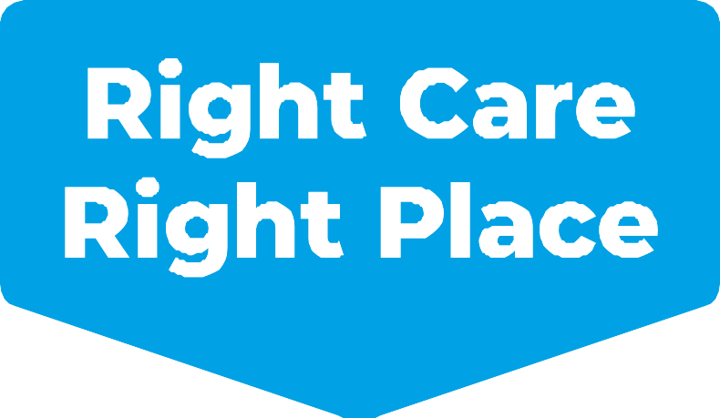
By calling 111 they can refer you to the best service. This might include a phone or video consultation with a qualified health professional. If you need to attend hospital in person they will give you an appointment.
Please only attend A&E, or dial 999, in a life threatening emergency.

For more information please visit: services.nhslothian.scot/rightcare

